Recipe Roundtable

Project Documentation

*Introduction*

Purpose:

Cooking is one of life’s most essential skills. I was horribly lacking in that category for most of my life. That all changed with my friends coming together and teaching each other some of our favorite recipes. I still remember the first class I “taught”. Frozen chicken tenderloins and some boiled broccoli. Mine was not a very popular dish. I was more of a takeout person.

The average home cooked meal costs about $4.31. The average takeout meal is $20.37. Only 60% of Americans cook at home more than 5 times per week, and over 40% of those people say they do not enjoy cooking.

Home cooking can be daunting. I know it was for me. So many choices of recipes and incredible professional level photos that leave your mouth watering. You try the same recipe, put in a ton of effort and it turns out poorly, and now you don’t want to cook anything the rest of the week. Recipe Roundtable is here to combat the fears of starting off as a home cook.

The idea of Recipe Roundtable was born during the lost years of the 2020s. The purpose was to have an easy-to-access place for friends and family to store recipes. Over this course, it has grown from a pipe dream, into a reality, and stepped past the point I thought I would be happy. I originally wanted an online cookbook that friends and families could use. But Recipe Roundtable has evolved into a site where eventually, anyone can share or store their own recipes and share them with friends.

Industry/Domain:

Currently, there are applications that allow users to store their own recipes. But I could not find anything outside of social media apps that allow you to share your creations with others. There is plenty of competition for recipe sites, but few that allow the roundtable comradery that Recipe Roundtable is aiming for.

Industry value chain:

1. Inbound Logistics

* Content Sourcing: Gathering diverse and high quality recipes. Vetting user generated content. Possible partnerships with food influencers or locally owned restaurants.
* Recipe Management: Properly tagging and categorizing recipes for easy retrieval and dinner helper. (cuisine categories, prep times, dietary restrictions, main ingredients)

1. Operations

* Site Development: Building and maintaining the website. Updating user interface and design. Integrating features recommended by users or as they come into scope of the project.
* Content Moderation: Ensure user recipes and profiles follow community guidelines.

1. Outbound Logistics:

* Distribution: Recipe accessibility through searches and recommendations. Access to favorites lists
* User notifications: Updates about recipes and any changes/notations. Notifications when someone favorites one of your recipes.

1. Marketing and Sales:

* User Acquisition: Attracting new users through social media, partners, or other means
* Engagement: Engaging with users through community blogs or newsletters

1. Service:

* User education: Offering tutorials on cooking, knife skills, food science.

1. Infrastructure:

* Security: Ensure secure web hosting, data security, and backup systems
* Scalability: Ensure site can scale as more users interact

**Key concepts to the Industry:**

1. Culinary Arts: Mastering cooking techniques(grilling, sous vide, baking, roasting, slow cooking, etc), knife skills (proper knife use, cut types and effects), plating.
2. Food Science: Understanding the science of flavor, mixing seasoning, and how ingredients interact when cooking.
3. Recipe Creation: Designing recipes that are feasible to the average cook.
4. Nutritional Needs: Understanding the various dietary restrictions(diabetics, allergies, vegan, vegetarians) and understanding what a balanced diet looks like.
5. Food Trends: Emerging trends from social media
6. Cultural and regional cuisine:Understanding and respecting traditional cooking methods and flavors from cultures and regions from around the world.
7. Fusion cuisine: Combining elements from different culinary traditions into creative and unique dishes

**Potential Industries:**

1. Retail: Possibly sell merchandise for Recipe Roundtable.

**Stakeholders:**

Users: who they are, interest, expectation

| Stakeholder | Identity | Interest | Expectation |
| --- | --- | --- | --- |
| Users | Groups of friends, families, etc | Allows them to find recipes and share their own and find meal with certain ingredients and difficulty | Reliability: recipe information is accurate on time and difficulty. Easy to find recipes. Can ask the savory sage what they think would be a good meal. |
| Contributors | Restaurants, Influencers | Allows them to share their recipes. | Easily upload and share recipes with users. Promote their brand on the site to dive business to |

*Product Description*

Architecture design:

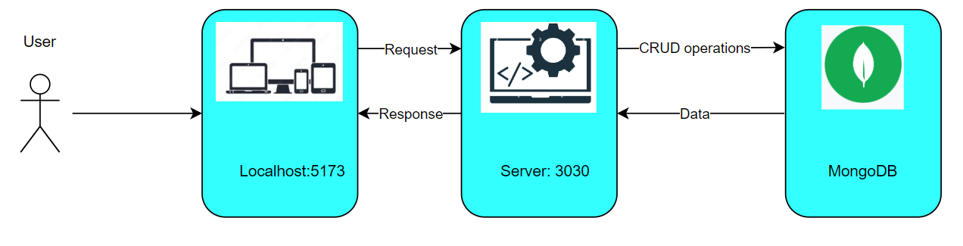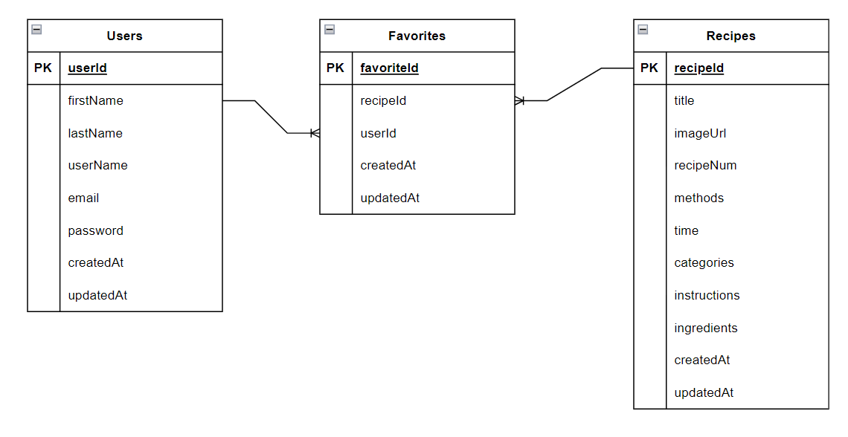

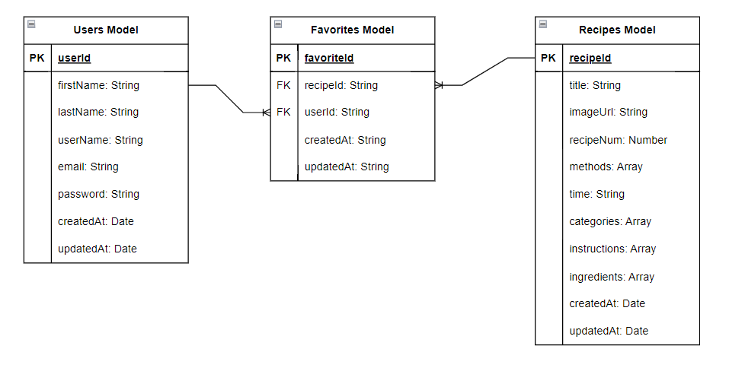

**User Stories**

| Title | Description | Priority | Notes |
| --- | --- | --- | --- |
| Landing Page | I want a landing page that immediately displays some recipes for me to try | High | Achieved |
| Browse Recipes | I want to be able to browse recipes by categories and other parameters | High | The user can browse recipes but cannot filter the recipes by many categories. |
| Recipe Information | I want to be able to see details on the recipe so that I can cook it for myself or family | High | Achieved, but I want to be able to give more information about the recipes including difficulty, substitutions and measurement calculators |
| Dinner Helper | I want a functionality to help me decide what I want for dinner | Medium | The Recipe Roulette system currently gives a random recipe, but I would like to be able to filter through using different parameters |
| Search Recipes | I want to be able to search for specific recipes using keywords | High | There is currently no way to search recipes and is a bit out of scope, looking to improve and add this feature. |
| User Registration | I want to be able to register to the site so I can begin sharing and storing my own recipes | Medium | Users as a feature came along deep in the project as I increased the scope of my idea. I would like this to eventually turn into social media-like environment with a focus on food and cooking |
| User Login | I want to be able to log into my account, add favorites, delete favorites, and see friends recipes | Medium |  |
| Add Recipes to Favorites | I want to be able to add recipes to my favorites so I can quickly access them | Low | Recipe favorites will be a feature added once the recipe database is much more filled. |
| Share Recipes with Friends | I want to be to share what I just cooked with my friends | Low |  |

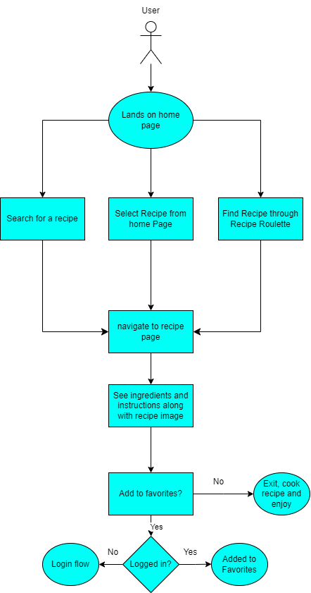

**Figma Designs:**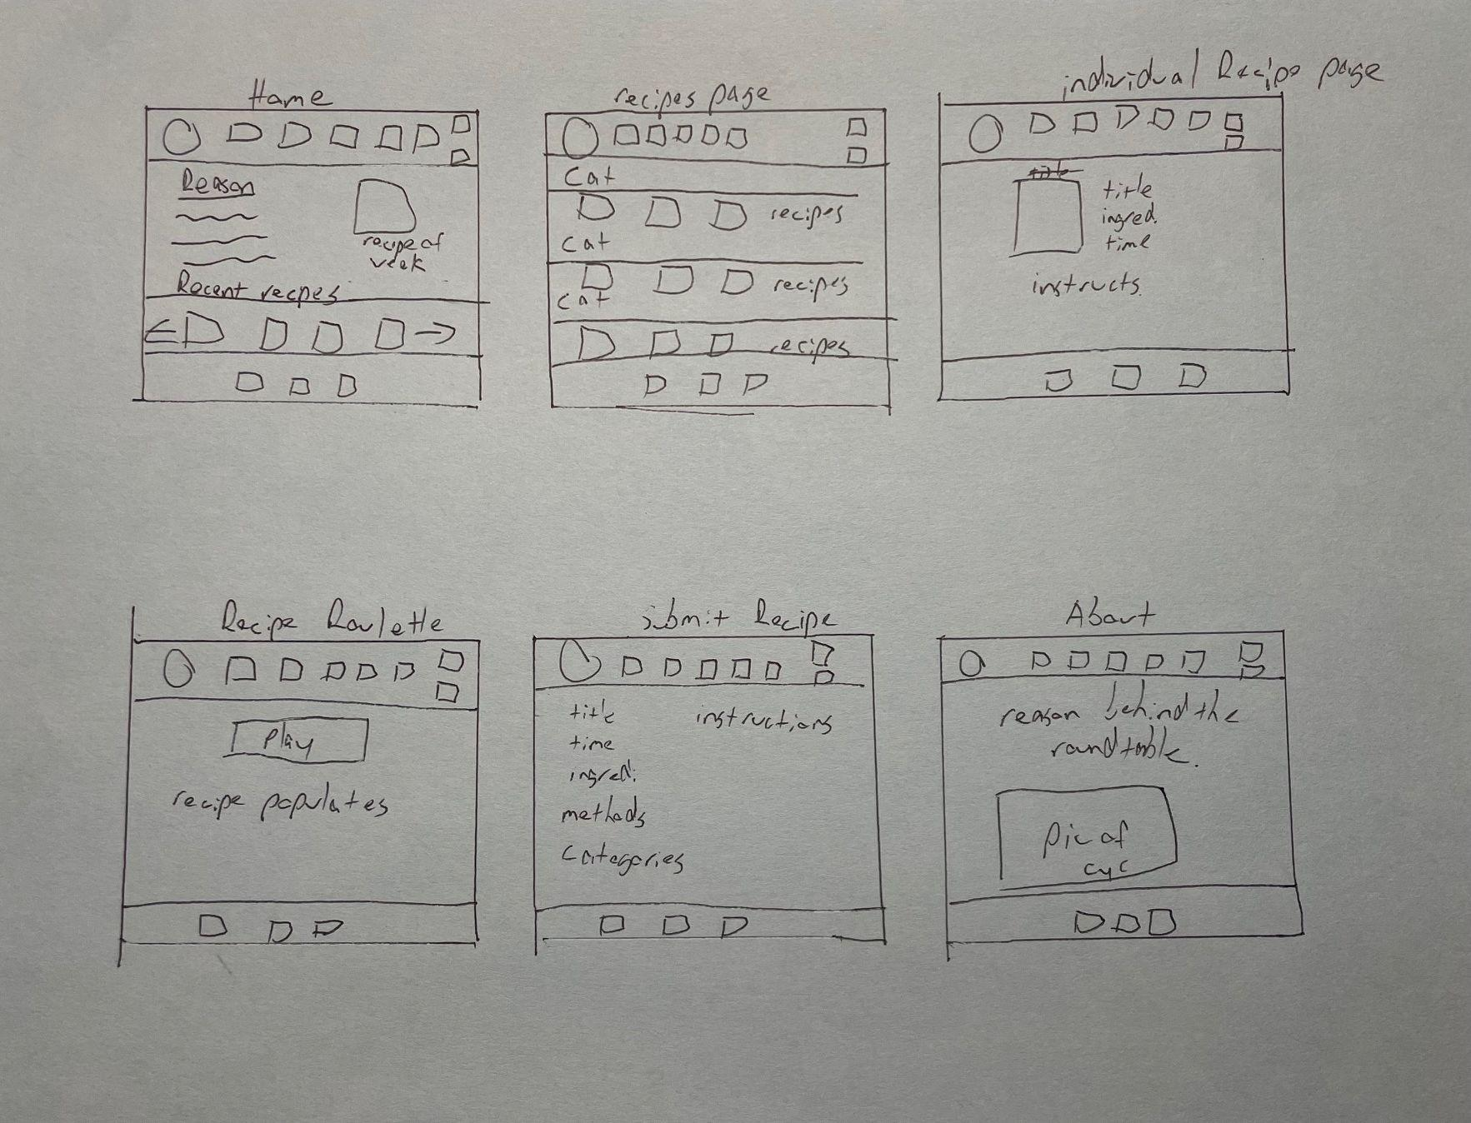

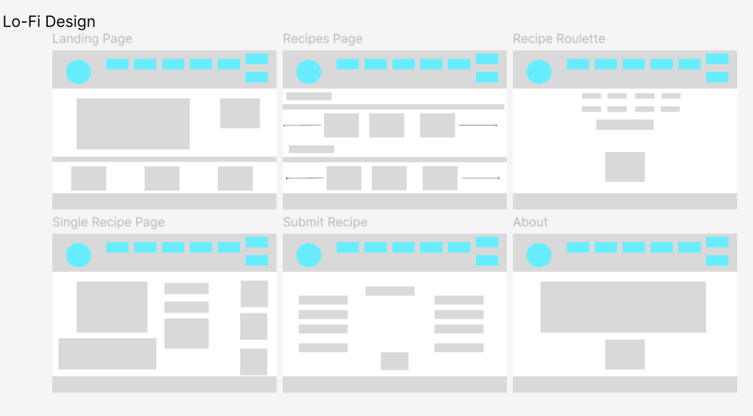

**Hi-Fi Design**

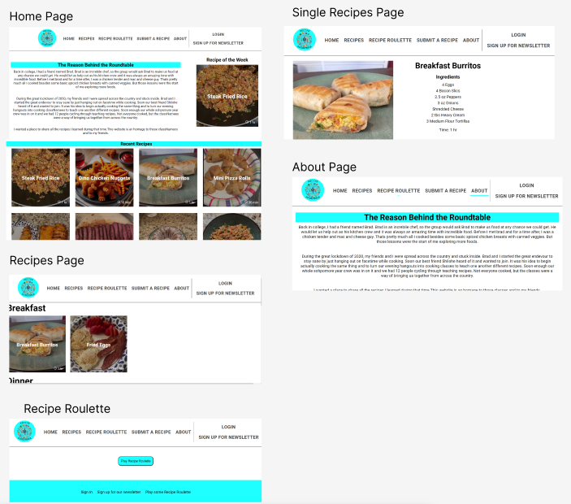

Open Questions - Out of Scope:

**Features that were out of scope:**

* Optimization for mobile - Creating a mobile app version
* User Authorization - Authorizing site managers to update or change recipes
* Integrating user recipes and sharing with friends
* Email newsletters - Will set up with mailchimp but is out of scope for now
* Linking with a CMS to manage recipe of the week or other content switches

**Open Questions:**

* Creating a submit recipe form - This was initially planned as a way for myself to log my own recipes. When it became clear to me that I wanted to expand the project to allow others to upload and share, this became a lower priority until I can handle user login and registration.
* Adding pagination or carousels to the recipes page once there are many more recipes.
* Would love to adjust styling and make plating/images more uniform and themed
* Adding Search recipe feature that can filter recipes based on preferences and dietary restrictions.
* Adding links to video tutorials for each recipe.
* Adding measurement calculators for when you wish to halve or increase the portion sizes.
* Adding measurement toggles to switch between metric and imperial measuring
* Adding Apparel Shop and links to possible influencer supporters
* Creating a newsletter sign up with integration through mailchimp or other EMS
* Ease of use - I want this to be used by anyone. Will have further testing with product testers/friends to test ease of use.

**Non-Functional Requirements:**

* Login - Currently no way to log in
* Recipe Roulette - Currently this is roulette in its truest form, completely random. I would like users to be able to “cheat” a bit and select desires or restrictions for their meal.
* Security measures like encryption need to be implemented before users are fully integrated so their profiles are secure.
* Locally ran - AWS would not accept my github. There are many features I would like implemented for other people to truly enjoy the site and it works for my purposes as is, so this was not high on the priority list.

*Product Planning:*

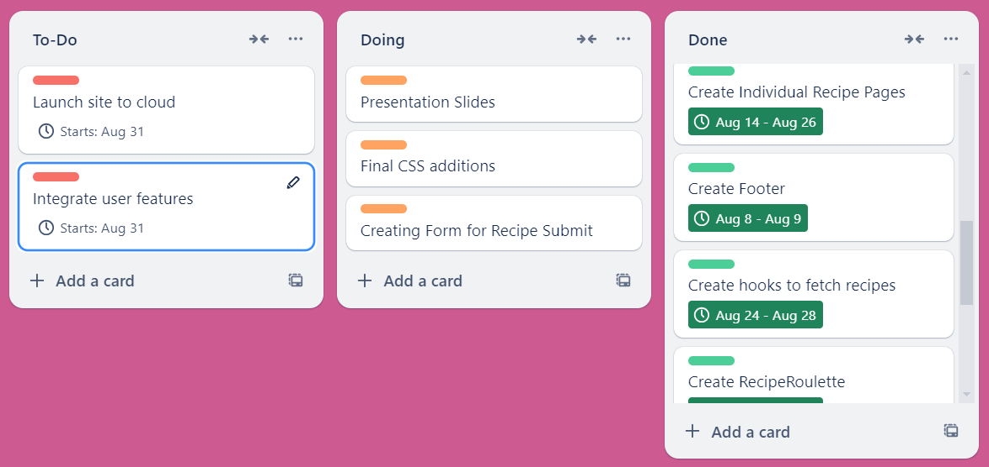

*Testing Strategy*

* Followed Figma and Draw.io designs
* Front-End tested meticulously with console.logs to ensure data is returning correctly and not causing too many renders
* Components were tested and any errors were resolved at the time of encounter
* Regular use of try catch other error handling within the code
* Thunderclient used to test CRUD operations
* Tested the application as a user to ensure no errors occurred.

*Implementation - Use for you own recipes*

**Deployment:**

* Server is run locally - Want to implement user features before launching.
* Server hosted on 3030, front-end hosted on 5173

**Implementation:**

* Pre-Requisites:
  + Visual Studio Code: <https://code.visualstudio.com/>
  + MongoDB Compass: <https://www.mongodb.com/try/download/shell>
  + Docker Desktop: <https://www.docker.com/products/docker-desktop/>
* Setup:
  + GitHub Repository:
    - <https://github.com/ThomasEllis1994/Recipe-RoundTable>
    - Clone or download as a zip file
  + Open repository in Visual Studios
    - Navigate to the front-end folder and install the packages
      * Npm install - will install all dependencies and dev dependencies
      * These include the following: 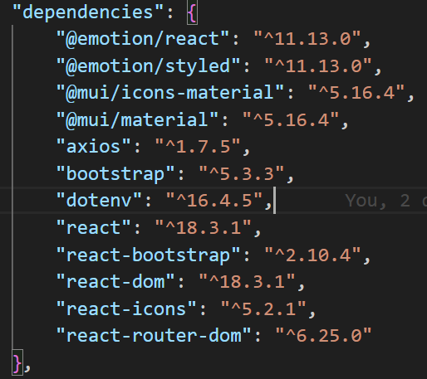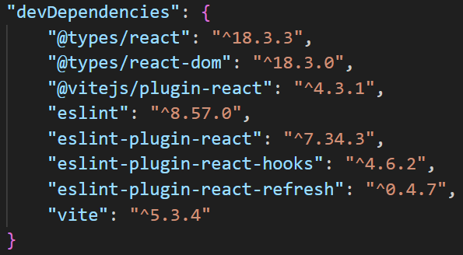
    - Next navigate to the server folder and do the same, Those dependencies include:
      * 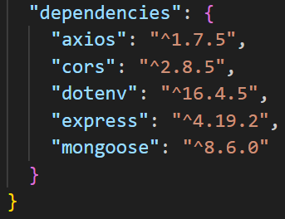
  + MongoDB set-up:
    - Open MongoDB compass and Docker Desktop
    - Create a docker instance to host mongoDB databases
    - Create a collection and change the DB_URI in your env file to link to the collection you want.
    - You are now ready to start storing your own recipes.
  + To launch the application, open two separate terminals with endpoints in the front-end and the server folders.
    - In the server folder, type the command, npm start.
    - In the front-end folder, type the command npm run dev and follow the link.
    - You now have your own recipe site.

*End-to-End Solution*

Currently, Recipe Roundtable has exceeded its initial dream of being a place to store my own recipes and those of my friends that I enjoyed. However, the project and scope evolved tremendously over the course of building the application and has a ways to go to fulfill the end dream of a place for people to share and store their own recipes. The database and datasets are fully integrated on local machines, but need to be deployed to the cloud. Many of the features are integrated but I would like to build them out beyond the scope of this course and project.

*References*

* Github Repository: <https://github.com/ThomasEllis1994/Recipe-RoundTable>
* MongoDB Compass:<https://www.mongodb.com/try/download/shell>
* Docker Desktop:<https://www.docker.com/products/docker-desktop/>
* Statistics: <https://www.testhut.com/how-many-americans-cook-statistics/>
* Slide template: <https://www.presentationgo.com/presentation/artisan-bakery-template-powerpoint-google-slides/>
* Back-End Packages
  + "axios": "^1.7.5",
  + "cors": "^2.8.5",
  + "dotenv": "^16.4.5",
  + "express": "^4.19.2",
  + "mongoose": "^8.6.0"
* Front-End Packages:
  + Dependencies
    - "@emotion/react": "^11.13.0",
    - "@emotion/styled": "^11.13.0",
    - "@mui/icons-material": "^5.16.4",
    - "@mui/material": "^5.16.4",
    - "axios": "^1.7.5",
    - "bootstrap": "^5.3.3",
    - "dotenv": "^16.4.5",
    - "react": "^18.3.1",
    - "react-bootstrap": "^2.10.4",
    - "react-dom": "^18.3.1",
    - "react-icons": "^5.2.1",
    - "react-router-dom": "^6.25.0"
  + Dev Dependencies:
    - "@types/react": "^18.3.3",
    - "@types/react-dom": "^18.3.0",
    - "@vitejs/plugin-react": "^4.3.1",
    - "eslint": "^8.57.0",
    - "eslint-plugin-react": "^7.34.3",
    - "eslint-plugin-react-hooks": "^4.6.2",
    - "eslint-plugin-react-refresh": "^0.4.7",
    - "vite": "^5.3.4"